**Face recognition based attendance system**



**A PROJECT REPORT**

*Submitted by*

**STU. NAME –Rahul Singh UID: 18BEM1005**

***In partial fulfillment for the award of the degree***

***of***

**BACHELOR OF ENGINEERING**

**in**

**MECHATRONICS ENGINEERING**

**Inderpreet Sir**

**Of**

**(Name of Guide)**

**University Institute of Engineering**

**CHANDIGARH UNIVERSITY**

**August – 2021**

**CHANDIGARH UNIVERSITY**

**BONAFIDE CERTIFICATE**

Certified that this project report **“Face recognition based attendance system’’**

is the bonafide work of “**Rahul Singh”**

**STU. NAME- Rahul Singh UID: 18BEM1005**

who carried out the work under my supervision. Certified further that to the best of my knowledge the work reported herein does not form part of any other thesis or dissertation on the basis of which a degree or award was conferred on an earlier occasion on this or any other candidate.

Signature of the Head of the Department Signature of the Supervisor

**SIGNATURE SIGNATURE**

<<Name>> <<Name>>

**HEAD OF THE DEPARTMENT SUPERVISOR**

<<Academic Designation>>

<<Department>> <<Department>>

<<Full address of the Dept & College >> <<Full address of the Dept & College >>

**CERTIFICATE FOR EVALUATION**

**College Name : University Institute of Engineering**

**Branch : Mechatronics Engineering.**

**Year / Semester: IV / VIII**

|  |  |  |  |
| --- | --- | --- | --- |
| **S.NO** | **Name of the Students**  **Who have done**  **the project** | **Title of the project** | **Name of the**  **Supervisor with**  **Designation** |
| **1.** | **Rahul Singh** | **Face recognition based attendance system** | **Mr. Inderpreet** |

The reports of the project work submitted by the above students in partial fulfillment for the award of Bachelor of Engineering degree in Mechatronics Engineering of Chandigarh University were evaluated and confirmed to be the reports of the work done by the above students and then evaluated.

**INTERNAL EXAMINER EXTERNAL EXAMINER**

Mr Inderpreet Singh Dr. Gurmeet Singh

**ACKNOWLEDGEMENT**

This project, though done by us would not have been possible, without the support of various people, who by their cooperation have helped us in bringing out this project successfully.

Our special heartfelt thanks to Chairperson **Prof.** for providing ate of art facility during project work.

We are grateful to our Principal, **Dr.**  for her patronage towards our project.

We thank our Professor & Head**, Dr.**  who had always served as an inspiration for us to perform well.

We would like to express our faithful thanks to **Supervisor Name,** for having extended all the department facilities without slightest hesitation.

We would like to express our unbounded gratefulness to **Mr.**  and **Mr.** for their valuable guidance and encouragement throughout the project.

We thank all faculty members and supporting staff for the help they extended to us for the completion of this project.

**ABSTRACT**

Face recognition is a powerful tool for a biometric system that takes data from both images and videos. Face recognition is a biometric based technology that maps an individual’s facial features mathematically and stores the data as a face print. It employs Machine Learning on the image and generates a feature vector which maps an object with array of numbers. In the past years a lot of effort has been made in the field of face detection. The human face contains important features that can be used by vision-based automated systems in order to identify and recognize individuals. Face location, the primary step of the vision-based automated systems, finds the face area in the input image. The main purpose of this project is to build a face recognition-based attendance monitoring system for educational institution to enhance and upgrade the current attendance system into more efficient and effective as compared to before. The human face is one of the natural traits that can uniquely identify an individual. Therefore, it is used to trace identity as the possibilities for a face to deviate or being duplicated is low.

Nowadays Educational institutions are concerned about regularity of student attendance. This is mainly due to students’ overall academic performance is affected by his or her attendance in the institute. Mainly there are two conventional methods of marking attendance which are calling out the roll call or by taking student sign on paper. They both were more time consuming and difficult. Hence, there is a requirement of computer-based student attendance management system which will assist the faculty for maintaining attendance record automatically

In this project we have implemented the automated attendance system using OpenCV . We have projected our ideas to implement “Face Recognition Based Attendance System”, in which it imbibes large applications. The application includes face identification, which saves time and eliminates chances of proxy attendance because of the face authorization. Hence, this system can be implemented in a field where attendance plays an important role.

**TABLE OF CONTENTS**

|  |  |
| --- | --- |
| **TITLE** | **PAGE NO.** |
| **ACKNOWLEDGEMENTS……………………………………………………** | i |
| **ABSTRACT…………………………………………………………………….** | ii |
| **TABLE OF CONTENTS………………………………………………………** | iii |
| **CHAPTER 1 INTRODUCTION** |  |
| 1.1 Introduction | 1 |
| 1.2 Definition of the Problem |  |
| 1.2.1 Problem Statement |  |
| 1.2.2 Need for Research |  |
| 1.4 Background Study |  |
| 1.5 Objective and Scope of Research |  |

|  |  |
| --- | --- |
| **CHAPTER 2 LITERATURE REVIEW** |  |
| 2.1 NFC Technology with Embedded Camera on Mobile Device. |  |
| 2.2 Fingerprint Based Attendance System Using Microcontroller and LabView  2.3 RFID based Student Attendance System  **CHAPTER 3: PROPOSED SYSTEM**  3.1 Libraries Development |  |
| **CHAPTER 4: SOFTWARE DEVELOPMENT** |  |
| 4.1 The creation of the face database  4.2 The process of attendance taking |  |
| **CHAPTER 5 METHODOLOGY** |  |
| 5.1 Image Acquisition and Pre-processing procedures  5.2 Hierarchy manner of the face database  5.3 Structure of the content in the csv file  5.4 Flow chart of the image acquisition process  5.5 Flow Chart of the image retrieval process  5.6 Problems Encountered And Their Solutions |  |
| **CHAPTER 6 RESULT AND DISCUSSION** |  |
| **CHAPTER 7 CONCLUSION AND FUTURE SCOPE OF WORK** |  |
| 7.1 Future Scope of Work  7.2 Conclusion  **CHAPTER 8 REFERENCES** |  |
|  |  |

**TABLE OF FIGURES**

________________________________________________

Figure 1-1 Photometric stereo image….............................................................................12

Figure 1-2 Geometric facial recognition............................................................................13

Figure 4-1 Creating Datset….............................................................................................14

Figure 4-2 Processing of Data............................................................................................15

Figure 5-1 Storing of Data……………... .........................................................................16

Figure 5-2 Image Acquisition………………....................................................................16

Figure 5-3 Hierarchy Manner……....................................................................................16

Figure 5-4 Flow Chart……................................................................................................17

Figure 6-1 Page UI………….............................................................................................18

Figure 6-2 Creating Dataset ……………………………………………………………..19

Figure 6-4 Capturing……………………..........................................................................19

Figure 6-4 Excel Sheet…………………………………………. .....................................19

Figure 6-5 Contact Info………………………………………………….........................20

**I. INTRODUCTION**

**1.1 Introduction**

In the recent years, Image processing which deals with extracting useful information from a digital image plays a unique role in the advent of technological advancements. It focusses on two tasks

• Improvement of pictorial information for human interpretation

• Processing of image data for storage, transmission and representation for autonomous machine perception.

Also people have started to use image capturing devices never as before with the advent of smart phones and closed circuit television. Since the application of image processing is vast, extensive work and research have been carrying out in utilizing its potential to and to make new innovative applications. Facial recognition has been the earliest of the application derived from this technology, which is one of the most fool proof methods in human detection. Face is a typical multidimensional structure and needs good computational analysis for recognition. Biometrics methods have been used for the same purpose since a long time now. Although it is effective, it is still not completely reliable for purpose of detecting a person.

* + 1. **FACE RECOGNIZATION:**

DIFFERENT APPROACHES OF FACE RECOGNITION:

There are two predominant approaches to the face recognition problem: Geometric (feature based) and photometric (view based). As researcher interest in face recognition continued, many different algorithms were developed, three of which have been well studied in face recognition literature.

Recognition algorithms can be divided into two main approaches:

1. Geometric: Is based on geometrical relationship between facial landmarks, or in other words the spatial configuration of facial features. That means that the main geometrical features of the face such as the eyes, nose and mouth are first located and then faces are classified on the basis of various geometrical distances and angles between features. Figure 1.2

2. Photometric stereo: Used to recover the shape of an object from a number of images taken under different lighting conditions. The shape of the recovered object is defined by a gradient map, which is made up of an array of surface normals (Zhao and Chellappa, 2006) Figure 1.1

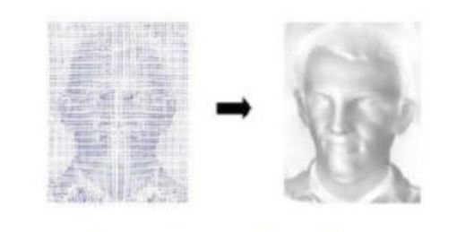

Figure 1.1 Photometric stereo image

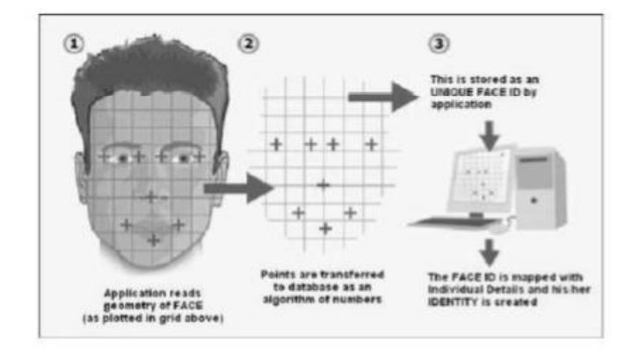

Figure 1.2 Geometric facial recognition

**Popular recognition algorithms include**:

1. EIGEN FACES

This method is a statistical plan. The characteristic which influences the images is derived by this algorithm. The whole recognition method will depend on the training database that will be provided. The images from two different classes are not treated individually.

1. FISHER FACES

Fisher faces algorithm also follows a progressive approach just like the Eigen faces. This method is a alteration of Eigen faces so it uses the same principal Components Analysis. The major conversion is that the fisher faces considers the classes. As mentioned previously, the Eigen faces does not differentiate between the two pictures from two differed classes while training. The total average affects each picture. A Fisher face employs Linear Discriminant Analysis for distinguishing between pictures from a different class.

1. LOCAL BINARY PATTERNS HISTOGRAMS

This method needs the gray scale pictures for dealing with the training part. This algorithm in comparison to other algorithms is not a holistic approach

* + 1. **FACE DETECTION:**

Face detection involves separating image windows into two classes; one containing faces (tarning the background (clutter). It is difficult because although commonalities exist between faces, they can vary considerably in terms of age, skin colour and facial expression. The problem is further complicated by differing lighting conditions, image qualities and geometries, as well as the possibility of partial occlusion and disguise. An ideal face detector would therefore be able to detect the presence of any face under any set of lighting conditions, upon any background. The face detection task can be broken down into two steps. The first step is a classification task that takes some arbitrary image as input and outputs a binary value of yes or no, indicating whether there are any faces present in the image. The second step is the face localization task that aims to take an image as input and output the location of any face or faces within that image as some bounding box with (x, y, width, height).

**The face detection system can be divided into the following steps:-**

**1. Pre-Processing:** To reduce the variability in the faces, the images are processed before they are fed into the network. All positive examples that is the face images are obtained by cropping images with frontal faces to include only the front view. All the cropped images are then corrected for lighting through standard algorithms.

**2. Classification:** Neural networks are implemented to classify the images as faces or nonfaces by training on these examples. We use both our implementation of the neural network and the Matlab neural network toolbox for this task. Different network configurations are experimented with to optimize the results.

**3. Localization:** The trained neural network is then used to search for faces in an image and if present localize them in a bounding box. Various Feature of Face on which the work has done on:- Position Scale Orientation Illumination

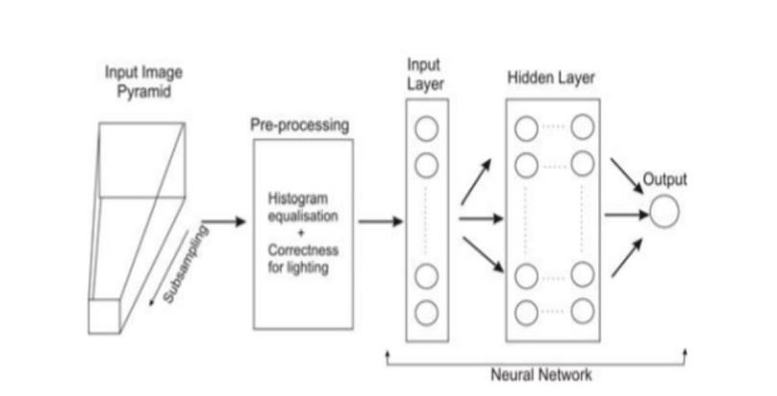

Figure 1.3 Face detection algorithm

**1.2 Definition of the problem**

**1.2.1 Problem Statement**

According to the previous attendance management system, the accuracy of the data collected is the biggest issue. This is because the attendance might not be recorded personally by the original person, in another word, the attendance of a particular person can be taken by a third party without the realization of the institution which violates the accuracy of the data. For example, student A is lazy to attend a particular class, so student B helped him/her to sign for the attendance which in fact student A didn’t attend the class, but the system overlooked this matter due to no enforcement practiced. Supposing the institution establish an enforcement, it might need to waste a lot of human resource and time which in turn will not be practical at all. Thus, all the recorded attendance in the previous system is not reliable for analysis usage. The second problem of the previous system is where it is too time consuming. Assuming the time taken for a student to sign his/her attendance on a 3-4 paged name list is approximately 1 minute. In 1 hour, only approximately 60 students can sign their attendance which is obviously inefficient and time consuming. The third issue is with the accessibility of those information by the legitimate concerned party. For an example, most of the parents are very concerned to track their child’s actual whereabouts to ensure their kid really attend the classes in college/school. However in the previous system, there are no ways for the parents to access such information. Therefore, evolution is needed to be done to the previous system to improve efficiency, data accuracy and provides accessibility to the information for those legitimate party.

**1.2.2 Research Objectives**

Face recognition can be applied for a wide variety of problems like image and film processing, human-computer interaction, criminal identification etc. This has motivated researchers to develop computational models to identify the faces, which are relatively simple and easy to implement. The existing system represents some face space with higher dimensionality and it is not effective too. The important fact which is considered is that although these face images have high dimensionality, in reality they span very low dimensional space. So instead of considering whole face space with high dimensionality, it is better to consider only a subspace with lower dimensionality to represent this face space. The goal is to implement the system (model) for a particular face and distinguish it from a large number of stored faces with some real-time variations as well. In order to solve the drawbacks of the previous system stated in 1.2.1, the existing system will need to evolve. The proposed system will reduce the paperwork where attendance will no longer involve any manual recording. The new system will also reduce the total time needed to do attendance recording. The new system will acquire individual attendance by means of facial recognition to secure data accuracy of the attendance.

**1.3 Background Study**

Many attendance management systems that exist nowadays are lack of efficiency and information sharing. Therefore, in this project, those limitations will be overcome and also further improved and are as follows:

* Students will be more punctual on attending classes. This is due to the attendance of a student can only be taken personally where any absentees will be noticed by the system. This can not only train the student to be punctual as well as avoids any immoral ethics such as signing the attendance for their friends.
* The institution can save a lot of resources as enforcement are now done by means of technology rather than human supervision which will waste a lot of human resource for an insignificant process.
* The application can operate on any device at any location as long as there is Wi-Fi coverage or Ethernet connection which makes the attendance system to be portable to be placed at any intended location. For an example, the device can be placed at the entrance of the classroom to take the attendance.
* It saves a lot of cost in the sense that it had eliminated the paperwork completely.
* The system is also time effective because all calculations are all automated. In short, the project is developed to solve the existing issues in the old attendance system.

**1.5 Objective and Scope of Research**

* To develop a portable Smart Attendance System which is handy and self-powered.
* Able to recognize the face of an individual accurately based on the face database.
* Allow parents to track their child’s attendance.
* Allow new students or staff to store their faces in the database by using a GUI.
* Able to show an indication to the user whether the face- recognition process is successful or not.

**II. LITERATURE REVIEW**

Face detection is a computer technology that determines the location and size of human face in arbitrary (digital) image. The facial features are detected and any other objects like trees, buildings and bodies etc are ignored from the digital image. It can be regarded as a ‗specific ‘case of object-class detection, where the task is finding the location and sizes of all objects in an image that belong to a given class. Face detection, can be regarded as a more ‗general ‘case of face localization. In face localization, the task is to find the locations and sizes of a known number of faces (usually one). Basically there are two types of approaches to detect facial part in the given image i.e. feature base and image base approach. Feature base approach tries to extract features of the image and match it against the knowledge of the face features. While image base approach tries to get best match between training and testing images.

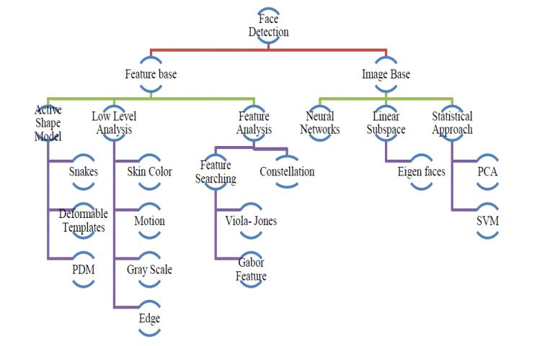

Figure 2.1 Detection methods

**2.1 FEATURE BASE APPROCH**:

Active Shape Model Active shape models focus on complex non-rigid features like actual physical and higher level appearance of features Means that Active Shape Models (ASMs) are aimed at automatically locating landmark points that define the shape of any statistically modelled object in an image. When of facial features such as the eyes, lips, nose, mouth and eyebrows. The training stage of an ASM involves the building of a statistical.

a) Facial model from a training set containing images with manually annotated landmarks. ASMs is classified into three groups i.e. snakes, PDM, Deformable templates

b) 1.1)Snakes: The first type uses a generic active contour called snakes, first introduced by Kass et al. in 1987 Snakes are used to identify head boundaries .In order to achieve the task, a snake is first initialized at the proximity around a head boundary. It then locks onto nearby edges and subsequently assume the shape of the head. The evolution of a snake is achieved by minimizing an energy function, Esnake (analogy with physical systems), denoted as Esnake = Einternal + EExternal WhereEinternal and EExternal are internal and external energy functions. Internal energy is the part that depends on the intrinsic properties of the snake and defines its natural evolution. The typical natural evolution in snakes is shrinking or expanding. The external energy counteracts the internal energy and enables the contours to deviate from the natural evolution and eventually assume the shape of nearby features—the head boundary at a state of equilibria. Two main consideration for forming snakes i.e. selection of energy terms and energy minimization. Elastic energy is used commonly as internal energy. Internal energy is vary with the distance between control points on the snake, through which we get contour an elastic-band characteristic that causes it to shrink or expand. On other side external energy relay on image features. Energy minimization process is done by optimization techniques such as the steepest gradient descent. Which needs highest computations. Huang and Chen and Lam and Yan both employ fast iteration methods by greedy algorithms. Snakes have some demerits like contour often becomes trapped onto false image features and another one is that snakes are not suitable in extracting non convex features.

**2.1.1 Deformable Templates:**

Deformable templates were then introduced by Yuille et al. to take into account the a priori of facial features and to better the performance of snakes. Locating a facial feature boundary is not an easy task because the local evidence of facial edges is difficult to organize into a sensible global entity using generic contours. The low brightness contrast around some of these features also makes the edge detection process. Yuille et al. took the concept of snakes a step further by incorporating global information of the eye to improve the reliability of the extraction process. Deformable templates approaches are developed to solve this problem. Deformation is based on local valley, edge, peak, and brightness .Other than face boundary, salient feature (eyes, nose, mouth and eyebrows) extraction is a great challenge of face recognition. E = Ev + Ee + Ep + Ei + Einternal; where Ev, Ee, Ep, Ei, Einternal are external energy due to valley, edges, peak and image brightness and internal energy

**2.1.2 PDM (Point Distribution Model):**

Independently of computerized image analysis, and before ASMs were developed, researchers developed statistical models of shape. The idea is that once you represent shapes as vectors, you can apply standard statistical methods to them just like any other multivariate object. These models learn allowable constellations of shape points from training example sand use principal components to build what is called a Point Distribution Model. These have been used in diverse ways, for example for categorizing Iron Age broaches. Ideal Point Distribution Models can only deform in ways that are characteristic of the object. Cootes and his colleagues were seeking models which do exactly that so if a beard, say, covers the chin, the shape model can override the image" to approximate the position of the chin under the beard. It was therefore natural (but perhaps only in retrospect) to adopt Point Distribution Models. This synthesis of ideas from image processing and statistical shape modelling led to the Active Shape Model. The first parametric statistical shape model for image analysis based on principal components of inter-landmark distances was presented by Cootes and Taylor in. On this approach, Cootes, Taylor, and their colleagues, then released a series of papers that cumulated in what we call the classical Active Shape Model.

**2.2) LOW LEVEL ANALYSIS:**

Based on low level visual features like color, intensity, edges, motion etc. Skin Color Base Color is avital feature of human faces. Using skin-color as a feature for tracking a face has several advantages. Color processing is much faster than processing other facial features. Under certain lighting conditions, color is orientation invariant. This property makes motion estimation much easier because only a translation model is needed for motion estimation. Tracking human faces using color as a feature has several problems like the color representation of a face obtained by a camera is influenced by many factors (ambient light, object movement, etc.

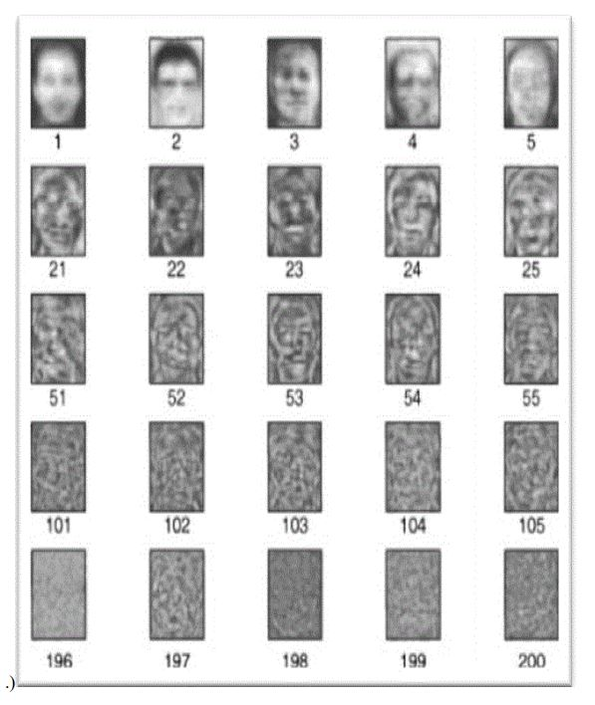

Figure 2.2 Face detection

Majorly three different face detection algorithms are available based on RGB, YCbCr, and HIS color space models.In the implementation of the algorithms there are three main steps viz.

(1) Classify the skin region in the color space,

(2) Apply threshold to mask the skin region and

(3) Draw bounding box to extract the face image.

Crowley and Coutaz suggested simplest skin color algorithms for detecting skin pixels. The perceived human color varies as a function of the relative direction to the illumination.

The pixels for skin region can be detected using a normalized color histogram, and can be normalized for changes in intensity on dividing by luminance. Converted an [R, G, B] vector is converted into an [r, g] vector of normalized color which provides a fast means of skin detection. This algorithm fails when there are some more skin region like legs, arms, etc. Cahi and Ngan suggested skin color classification algorithm with YCbCr color space. Research found that pixels belonging to skin region having similar Cb and Cr values. So that the thresholds be chosen as [Cr1, Cr2] and [Cb1, Cb2], a pixel is classified to have skin tone if the values [Cr, Cb] fall within the thresholds. The skin color distribution gives the face portion in the color image. This algorithm is also having the constraint that the image should be having only face as the skin region. Kjeldson and Kender defined a color predicate in HSV color space to separate skin regions from background. Skin color classification in HSI color space is the same as YCbCr color space but here the responsible values are hue (H) and saturation (S). Similar to above the threshold be chosen as [H1, S1] and [H2, S2], and a pixel is classified to have skin tone if the values [H,S] fall within the threshold and this distribution gives the localized face image. Similar to above two algorithm this algorithm is also having the same constraint

**2.3) MOTION BASE:**

When use of video sequence is available, motion information can be used to locate moving objects. Moving silhouettes like face and body parts can be extracted by simply thresholding accumulated frame differences. Besides face regions, facial features can be located by frame differences.

**2.3.1 Gray Scale Base:**

Gray information within a face can also be treat as important features. Facial features such as eyebrows, pupils, and lips appear generally darker than their surrounding facial regions. Various recent feature extraction algorithms search or local gray minima within segmented facial regions. In these algorithms, the input images are first enhanced by contrast-stretching and gray-scale morphological routines to improve the quality of local dark patches and thereby make detection easier. The extraction of dark patches is achieved by low-level gray-scale thresholding. Based method and consist three levels. Yang and huang presented new approach i.e. faces gray scale behavior in pyramid (mosaic) images. This system utilizes hierarchical Face location consist three levels. Higher two level based on mosaic images at different resolution. In the lower level, edge detection method is proposed. Moreover this algorithms gives fine response in complex background where size of the face is unknown.

**2.3.2 Edge Base:**

Face detection based on edges was introduced by Sakai et al. This work was based on analyzing line drawings of the faces from photographs, aiming to locate facial features. Than later Craw et al. proposed a hierarchical framework based on Sakai et al. ‘swork to trace a human head outline. Then after remarkable works were carried out by many researchers in this specific area. Method suggested by Anila and Devarajan was very simple and fast. They proposed frame work which consist three steps i.e. initially the images are enhanced by applying median filter for noise removal and histogram equalization for contrast adjustment. In the second step the edge images constructed from the enhanced image by applying sobel operator. Then a novel edge tracking algorithm is applied to extract the sub windows from the enhanced image based on edges. Further they used Back propagation Neural Network (BPN) algorithm to classify the sub-window as either face or non-face.

**2.4 FEATURE ANALYSIS**

These algorithms aim to find structural features that exist even when the pose, viewpoint, or lighting conditions vary, and then use these to locate faces. These methods are designed mainly for face localization

**2.4.1 Feature Searching**

**Viola Jones Method:**

Paul Viola and Michael Jones presented an approach for object detection which minimizes computation time while achieving high detection accuracy. Paul Viola and Michael Jones proposed a fast and robust method for face detection which is 15 times quicker than any technique at the time of release with 95% accuracy at around 17 fps. The technique relies on the use of simple Haar-like features that are evaluated quickly through the use of a new image representation. Based on the concept of an ―Integral Image‖ it generates a large set of features and uses the boosting algorithm Ada Boost to reduce the over complete set and the introduction of a degenerative tree of the boosted classifiers provides for robust and fast interferences. The detector is applied in a scanning fashion and used on gray-scale images, the scanned window that is applied can also be scaled, as well as the features evaluated.

**Gabor Feature Method:**

Sharif et al proposed an Elastic Bunch Graph Map (EBGM) algorithm that successful implements face detection using Gabor filters. The proposed system applies 40 different Gabor filters on an image. As a result of which 40 images with different angles and orientation are received. Next, maximum intensity points in each filtered damage are calculated and mark them as fiducial points. The system reduces these points in accordance to distance between them. The next step is calculating the distances between the reduced points

Using distance formula. At last, the distances are compared with database. If match occurs, it means that the faces in the image are detected. Equation of Gabor filter is shown below`

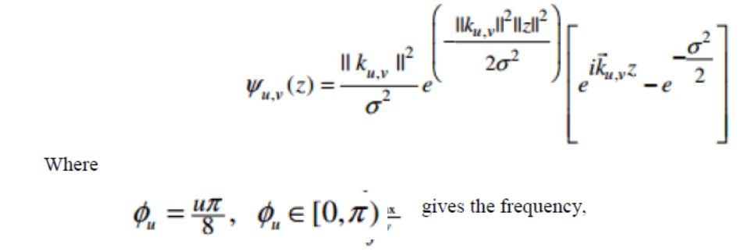

**2.5 CONSTELLATION METHOD**

All methods discussed so far are able to track faces but still some issue like locating faces of various poses in complex background is truly difficult. To reduce this difficulty investigator form a group of facial features in face-like constellations using more robust modelling approaches such as statistical analysis. Various types of face constellations have been proposed by Burl et al. They establish use of statistical shape theory on the features detected from a multiscale Gaussian derivative filter. Huang et al. also apply a Gaussian filter for pre-processing in a framework based on image feature analysis. Image Base Approach.

**2.5.1 Neural Network**

Neural networks gaining much more attention in many pattern recognition problems, such as OCR, object recognition, and autonomous robot driving. Since face detection can be treated as a two class pattern recognition problem, various neural network algorithms have been proposed. The advantage of using neural networks for face detection is the feasibility of training a system to capture the complex class conditional density of face patterns. However, one demerit is that the network architecture has to be extensively tuned (number of layers, number of nodes, learning rates, etc.) to get exceptional performance. In early days most hierarchical neural network was proposed by Agui et al. The first stage having two parallel subnetworks in which the inputs are filtered intensity values from an original image. The inputs to the second stage network consist of the outputs from the sub networks and extracted feature values. An output at the second stage shows the presence of a face in the input region. Propp and Samal developed one of the earliest neural networks for face detection. Their network consists of four layers with 1,024 input units, 256 units in the first hidden layer, eight units in the second hidden layer, and two output units. Feraud and Bernier presented a detection method using auto associative neural networks. The idea is based on which shows an auto associative network with five layers is able to perform a nonlinear principal component analysis. One auto associative network is used to detect frontalview faces and another one is used to detect faces turned up to 60 degrees to the left and right of the frontal view. After that Lin et al. presented a face detection system using probabilistic decision-based neural network (PDBNN). The architecture of PDBNN is similar to a radial basis function (RBF) network with modified learning rules and probabilistic interpretation

**2.6 LINEAR SUB SPACE METHOD**

**Eigen faces Method:**

An early example of employing eigen vectors in face recognition was done by Kohonen in which a simple neural network is demonstrated to perform face recognition for aligned and normalized face images. Kirby and Sirovich suggested that images of faces can be linearly encoded using a modest number of basis images. The idea is arguably proposed first by Pearson in 1901 and then by HOTELLING in 1933 .Given a collection of n by m pixel training. Images represented as a vector of size m X n, basis vectors spanning an optimal subspace are determined such that the mean square error between the projection of the training images onto this subspace and the original images is minimized. They call the set of optimal basis vectors Eigen pictures since these are simply the Eigen vectors of the covariance matrix computed from the vectorized face images in the training set. Experiments with a set of 100 images show that a face image of 91 X 50 pixels can be effectively encoded using only50 Eigen pictures A reasonable likeness (i.e., capturing 95 percent of the variance)

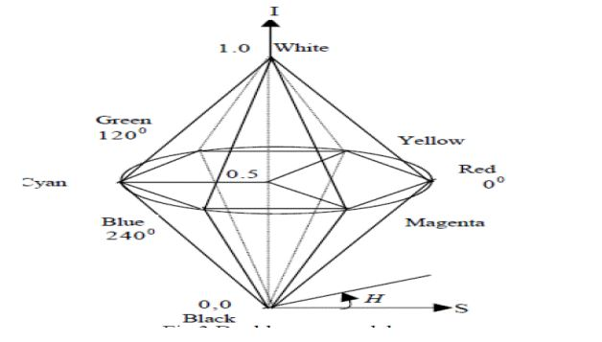

**2.7 STATISTICAL APPROCH**

**Support Vector Machine (SVM):**

SVMs were first introduced Osuna et al. for face detection. SVMs work as a new paradigm to train polynomial function, neural networks, or radial basis function (RBF) classifiers. SVMs works on induction principle, called structural risk minimization, which targets to minimize an upper bound on the expected generalization error. An SVM classifier is a linear classifier where the separating hyper plane is chosen to minimize the expected classification error of the unseen test patterns. In Osunaet al. developed an efficient method to train an SVM for large scale problems, and applied it to face detection. Based on two test sets of 10,000,000 test patterns of 19 X 19 pixels, their system has slightly lower error rates and runs approximately30 times faster than the system by Sung and Poggio . SVMs have also been used to detect faces and pedestrians in the wavelet domain.

**2.8 Attendance System Using NFC Technology with Embedded Camera on Mobile Device.**

According to research journal “Attendance System Using NFC (Near Field Communication) Technology with Embedded Camera on Mobile Device” (Bhise, Khichi, Korde, Lokare, 2015). The attendance system is improved by using NFC technology and mobile application. According to the research paper, each student is given a NFC tag that has a unique ID during their enrolment into the college. Attendance of each class will then be taken by touching or moving these tags on the lecturer mobile phone. The embedded camera on the phone will then capture the student’s face to send all the data to the college server to do validation and verification. The advantages of this method is where the NFC is simple to use, and the speed of connection establishment is very high. It indeed speeds up the attendance taking process a lot. However, this system couldn’t automatically spot the violation when the NFC tag is not personally tagged by the original owner. Apart from that, the convenience of the system which uses the mobile phone as the NFC reader was actually an inconvenience to the lecturer. Imagine if the lecturer had forgotten to bring their mobile phones to work, what would be the backup procedure for the attendance to be recorded? Moreover, most of the lecturer will not likely to prefer their personal smart phones to be used in this way due to privacy matter. Hence, unique information about the student like biometrics or face recognition, which is guanine for a student should be used in replacement of the NFC tag. This will ensure attendance to be taken originally by the actual student**.**

**2.9 Face Recognition Based Attendance Marking System**

The second research journals “Face Recognition Based Attendance Marking System” (SenthamilSelvi, Chitrakala, Antony Jenitha, 2014) is based on the identification of face recognition to solve the previous attendance system’s issues. This system uses camera to capture the images of the employee to do face detection and recognition. The captured image is compared one by one with the face database to search for the worker’s face where attendance will be marked when a result is found in the face database. The main advantage of this system is where attendance is marked on the server which is highly secure where no one can mark theattendance of other. Moreover, in this proposed system, the face detection algorithm is improved by using the skin classification technique to increase the accuracy of the detection process. Although more efforts are invested in the accuracy of the face detection algorithm, the system is yet not portable. This system requires a standalone computer which will need a constant power supply that makes it not portable. This type of system is only suitable for marking staff’s attendance as they only need to report their presence once a day, unlike students which require to report their attendance at every class on a particular day, it will be inconvenient if the attendance marking system is not portable. Thus, to solve this issue, the whole attendance management system can be developed on a portable module so that it can be work just by executing the python program.

**2.10 Fingerprint Based Attendance System Using Microcontroller and LabView**

The third research journal “Fingerprint Based Attendance System Using Microcontroller and LabVIEW” (Kumar Yadav, Singh, Pujari, Mishra, 2015) proposed a solution of using fingerprint to mark the attendance. This system is using 2 microcontrollers to deal with the fingerprint recognition process. Firstly, the fingerprint pattern will be obtained through a fingerprint sensor, then the information will be transmitted to microcontroller 1. Next microcontroller 1 will pass the information to microcontroller 2 to do the checking with the database that resides in it. After finding a student’s match, the details are sent to the PC through serial communication to be displayed. This design is good as it accelerates development while maintaining design flexibility and simplifies testing. But again, this system is attached to a PC which make it not portable. Other than that, the database information cannot be accessible easily. Meaning that, for the parents whom are interested in knowing their child’s attendance cannot easily or conveniently access the information. Therefore, to provide accessibility of the student’s information to the legitimate concerned party, the information can be uploaded to a web server for easy access. While the authentication for the appropriate access can be enforced through a login screen.

**2.11 RFID based Student Attendance System**

According to the fourth research journal “RFID based Student Attendance System” (Hussain, Dugar, Deka, Hannan, 2014), the proposed solution is almost similar to the first research journal where RFID technology is used to improve the older attendance system. In this system, a tag and a reader is again used as a method of tracking the attendance of the students. The difference between the first journals with this is where attendance’s information can be accessed through a web portal. It provides more convenient for information retrieval. Again, this system is imperfect in the sense that, firstly, it is not portable, as the RFID reader can only work when it is connected to a PC. Secondly, the RFID tag is not a guanine information that can uniquely identify a student, thus, resulting in the inaccuracy of the collected attendance information In conclusion, a better attendance monitoring system should be developed based on its portability, accessibility and the accuracy of the collected attendance information

**III. PROPOSED SYSTEM**

The present system of attendance marking i.e., manually calling out the roll call by the faculty have quite satisfactorily served the purpose. With the change in the educational system with the introduction of new technologies in classroom such as virtual classroom, the traditional way of taking attendance may not be viable anymore. Even with rising number of course of study offered by universities, processing of attendance manually could be time consuming. Hence, in our project we aim at creating a system to take attendance using facial recognition technology in classrooms and creating an efficient database to record them. The design part of the attendance monitoring system is divided into two sections which consist of the hardware and the software part. Before the software. The design part can be developed, the hardware part is first completed to provide a platform for the software to work. Before the software part we need to install some libraries for effective working of the application. We install OpenCV and Numpy through Python.

**3.1 Libraries development**

**3.1.1 OPENCV**

OpenCV (Open source computer vision) is a library of programming functions mainly aimed at real-time computer vision. The OpenCV project was initially an Intel Research initiative to advance CPU-intensive applications, part of a series of projects including real-time raytracing and 3Ddisplay walls. The main contributors to the project included several optimization experts in Intel Russia, as well as Intel's Performance Library Team.

In the early days of OpenCV, the goals of the project were described as:

• Advance vision research by providing not only open but also optimized code for basic vision infrastructure. No more reinventing the wheel.

• Disseminate vision knowledge by providing a common infrastructure that developers could build on, so that code would be more readily readable and transferable.

• Advance vision-based commercial applications by making portable, performance-optimized code available for free – with a license that did not require code to be open or free itself.

**OpenCV's application areas include:**

* 2D and 3D feature toolkits
* Egomotion estimation
* Facial recognition system
* Gesture recognition
* Human–computer interaction (HCI)
* Mobile robotics
* Motion understanding
* Object identification
* Segmentation and recognition
* Stereopsis stereo vision: depth perception from 2 cameras
* Structure from motion (SFM)
* Motion tracking
* Augmented reality To support some of the above areas, OpenCV includes a statistical machine learning library that contains:
* Boosting
* Decision tree learning
* Gradient boosting trees
* Expectation-maximization algorithm
* k-nearest neighbour algorithm
* Naive Bayes classifier
* Artificial neural networks
* Random forest
* SVM

**3.1.2 Numpy**

NumPy is a package that defines a multi-dimensional array object and associated fast math functions that operate on it. It also provides simple routines for linear algebra and fft and sophisticated random-number generation. NumPy replaces both Numeric and Numarray.

**3.2 DIGITAL IMAGE PROCESSING**

Interest in digital image processing methods stems from two principal application areas:

1. Improvement of pictorial information for human interpretation

2. Processing of scene data for autonomous machine perception

In this second application area, interest focuses on procedures for extracting image information in a form suitable for computer processing.

Examples includes automatic character recognition, industrial machine vision for product assembly and inspection, military recognizance, automatic processing of fingerprints etc.

**Image:**

Am image refers a 2D light intensity function f(x, y), where(x, y) denotes spatial coordinates and the value of f at any point (x, y) is proportional to the brightness or gray levels of the image at that point. A digital image is an image f(x, y) that has been discretized both in spatial coordinates and brightness. The elements of such a digital array are called image elements or pixels.

**A simple image model:**

To be suitable for computer processing, an image f(x, y) must be digitalized both spatially and in amplitude. Digitization of the spatial coordinates (x, y) is called image sampling. Amplitude digitization is called gray-level quantization.The storage and processing requirements increase rapidly with the spatial resolution and the number of gray levels.

Example: A 256 gray-level image of size 256x256 occupies 64k bytes of memory

**Types of image processing**

* + Low level processing
  + Medium level processing
  + High level processing

Low level processing means performing basic operations on images such as reading an image resize, resize, image rotate, RGB to gray level conversion, histogram equalization etc…, The output image obtained after low level processing is raw image. Medium level processing means extracting regions of interest from output of low level processed image. Medium level processing deals with identification of boundaries i.e edges .This process is called segmentation. High level processing deals with adding of artificial intelligence to medium level processed signal

**3.3 FUNDAMENTAL STEPS IN IMAGE PROCESSING**

**Fundamental steps in image processing are**

1. Image acquisition: to acquire a digital image

2. Image pre-processing: to improve the image in ways that increases the chances for success of the other processes.

3. Image segmentation: to partitions an input image into its constituent parts of objects.

4. Image segmentation: to convert the input data to a from suitable for computer processing.

5. Image description: to extract the features that result in some quantitative information of interest of features that are basic for differentiating one class of objects from another.

6. Image recognition: to assign a label to an object based on the information provided by its description.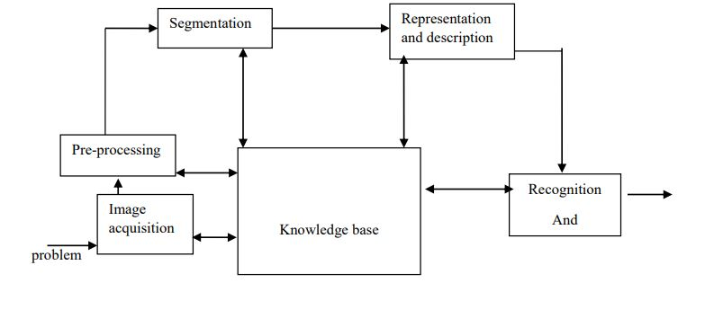

Figure 3.1 Fundamental steps in digital image processing

**3.4 ELEMENTS OF DIGITAL IMAGE PROCESSING SYSTEMS**

A digital image processing system contains the following blocks as shown in the figure

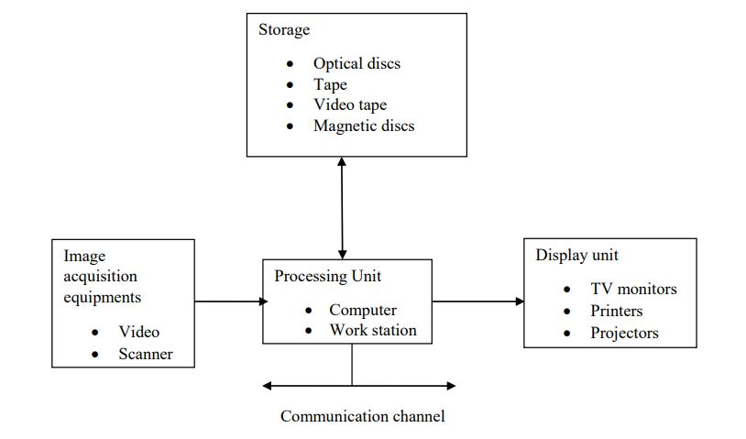

Figure 3.2 Elements of digital image processing systems

The basic operations performed in a digital image processing system include

1. Acquisition
2. Storage
3. Processing
4. Communication
5. Display

**IV. SOFTWARE DEVELOPMENT**

There are two major system flows in the software development section as shown below:

* The creation of the face database
* The process of attendance taking

Both processes mentioned above are essential because they made up the backbone of the attendance management system. In this section, the process of both flows will be briefly described. Meanwhile, their full functionality, specific requirements and also the methods/approach to accomplish such objectives will be discussed in the upcoming chapter.

**4.1 The creation of the face database:**

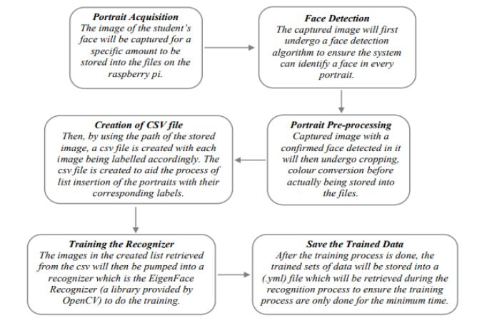

Figure 4.1 :Creating Database

The face database is an important step to be done before any further process can be initiated. This is because the face database acts as a comparison factor during the recognition process which will be discussed in later section. In the process above, a csv file is created to aid the process of image labelling because there will be more than one portrait stored for each student, thus, in order to group their portraits under the name of the same person, labels are used to distinguish them. After that, those images will be inserted into a recognizer to do its training. Since the training process is very time consuming as the face database grew larger, the training is only done right after there is a batch of new addition of student‟s portraits to ensure the training is done as minimum as possible.

**4.2 The process of attendance taking:**

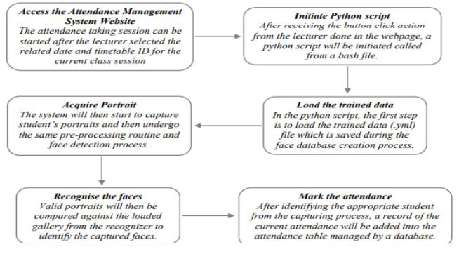

Figure 4.2: Processing of Data

**V. METHODOLOGY**

Before the attendance management system can work, there are a set of data needed to be inputted into the system which essentially consist of the individual’s basic information which is their ID and their faces. The first procedure of portrait acquisition can be done by using the Camera to capture the faces of the individual. In this process the system will first detect the presence of a face in the captured image, if there are no face detected, the system will prompt the user to capture their face again until it meets certain number of portraits which will be 10 required portraits in this project for each student. The decision of storing only 10 portrait per student is due to the consideration of the limited storage space in the raspberry pi because the total amount of students in the university is considered heavy. Then, the images will undergo several pre-processing procedures to obtain a grayscale image and cropped faces of equal sized images because those are the prerequisites of using the EigenFaces Recognizer. Both of the processes mentioned above can be represented in the diagram below

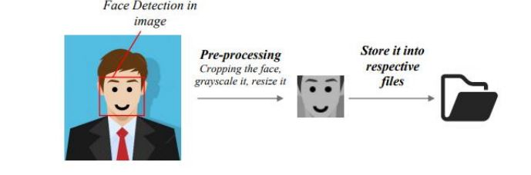

Figure: 5.1 Storing of data

**5.1 Image Acquisition and Pre-processing procedures**

After the images are being processed, they are stored into a file in a hierarchy manner. In this project, all the faces will be stored in a hierarchy manner under the „database‟ folder. When expanding through the database folder, there will consist of many sub-folders which each of them will represent an individual where a series of face portrait belonging to the same individual will be stored in that particular sub-folder. The sub-folders that represent each individual will be named upon the ID no. of that individual which is unique for every single individual in the institution. The whole process of image retrieval, pre-processing, storing mechanism is done by the script named create_database.py

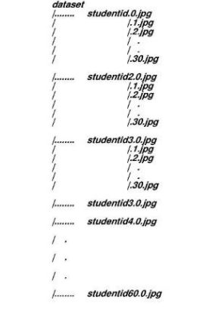

Figure 5.2 :Image Acquisition

**5.2 Hierarchy manner of the face database**

After a successful retrieval of facial images into the respective folder, a CSV files created to aid the next process of pumping the faces into the recognizer for the training process. The creation of the CSV file will be done based on a script named create_csv.py. In this project, the content of CSV file will look like the following format:

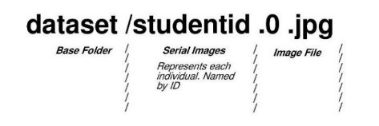

Figure 5.2 :Hierarchy manner

**5.3 Structure of the content in the csv file**

After having sufficient images in the database, those images will then be inserted into a training mechanism. There are generally 3 different types of training mechanism provided in OpenCV 3.4 which are EigenFaces, FisherFaces, and Local Binary Patterns Histograms (LBPH). The recognizer that will be focused in this project will be the EigenFaces recognizer. The concept behind EigenFaces is simple – it recognizes a particular face by catching the maximum deviation in a face and then turning those identified variations into information to be compared when a new face arrives. In the training process, the csv file will be read to provide the path to all of the images where those images and labels will be loaded into a list variable. Then, the list will be passed into the training function where the training process will take a measurable time to run. The larger the face database, the longer the time will be needed to train those images.

**5.4 Flow chart of the image acquisition process**

The development of the face database is an important phase before any facial recognizing process can be carried out. It acts as a library to compare against with whenever the system wanted to identify a person. In the image retrieval process, the system will first prompt for an input from the user to enter their ID number. The system will then validate the entered input and then check for duplication in the system. In order to proceed, the entered input must contain only 12 digits of number. Apart from that, the ID inputted have to be a non-registered ID to ensure no duplication. After that, a directory is created for each individual where their portraits will be stored inside of it. It is a compulsory to store 10 - 30 portraits per person in the file. After the acquisition of image is done, the images undergo a pre-processing before storing it into the respective folder

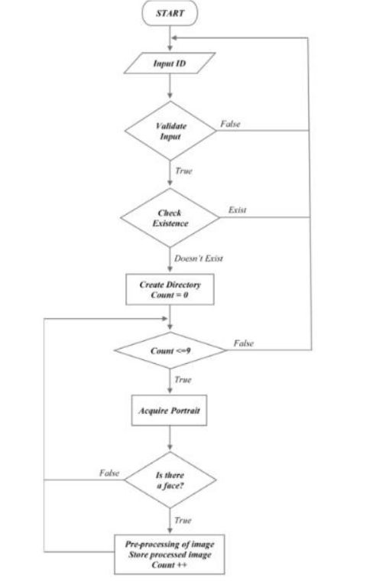

Figure 5.3 :Flow Chart

**5.5 Flow Chart of the image retrieval process**

The above flowchart is only the program flow for the image acquisition process which describes the program flow for the script create_database.py. There are two more python scripts that responsible for the remaining execution which will be explained in the next sub-section.

**5.6 Problems Encountered And Their Solutions**

**5.6.1 It only supports a few programming languages**

Even though OpenCV offers more than 3000 optimized algorithms, it only offers them for a small number of programming languages, namely C/C++, Python and Java for Android. However, wrapper libraries have been developed for other languages to encourage adoption by a wider audience.

**Solution:** An organization named Byte deco, who constantly work on adapting C/C++ libraries to Java, have made an OpenCV library for Java and was later adapted to work with Scala. This library was used for having face detection work in real-time on a webcam feed.

**VI. RESULT AND DISCUSSION**

Using the all the functions we have created, we have tested for output in using existing test images as well as in real-time. Following section, the screenshots of the output of different functions are given.

**6.1 Page UI**

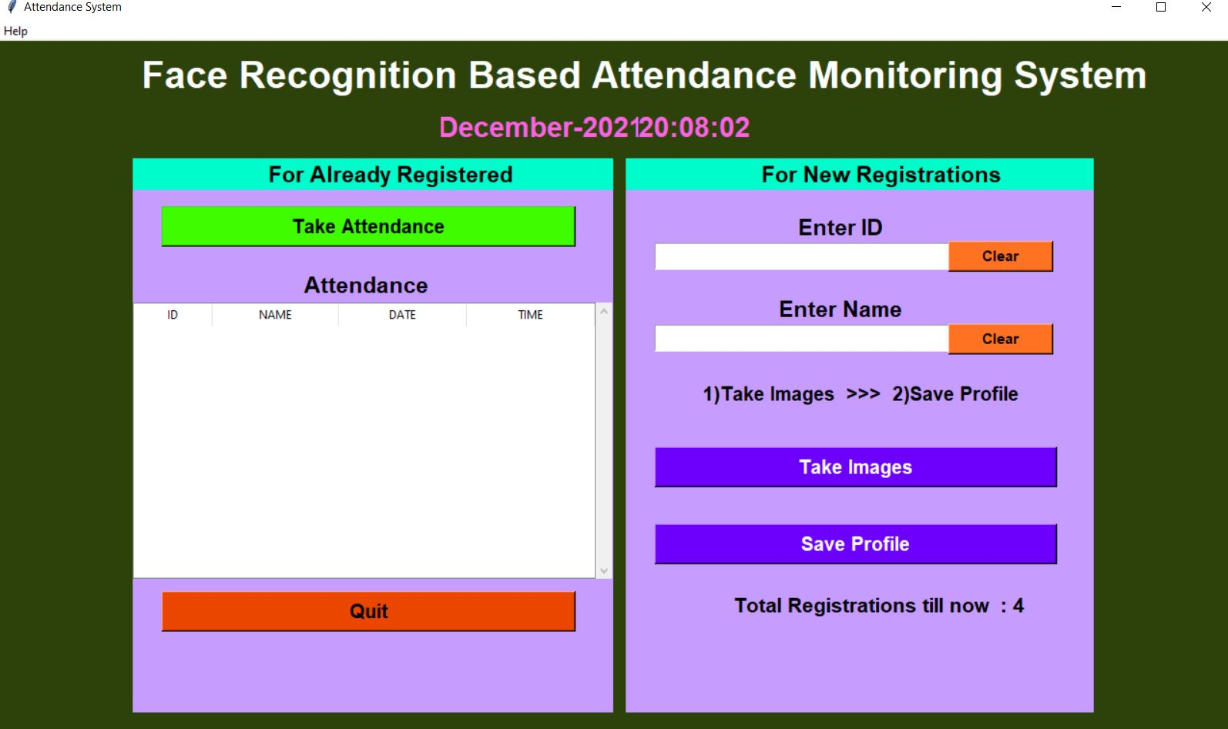

**6.2 Creating Dataset and Capturing**

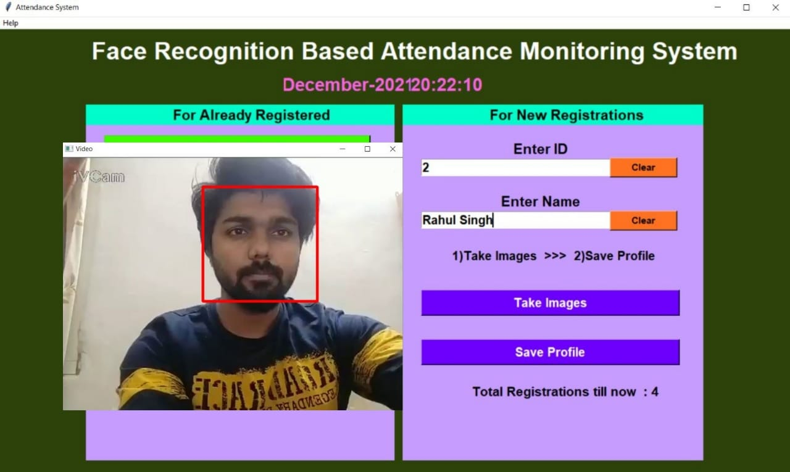

**6.3 Database**

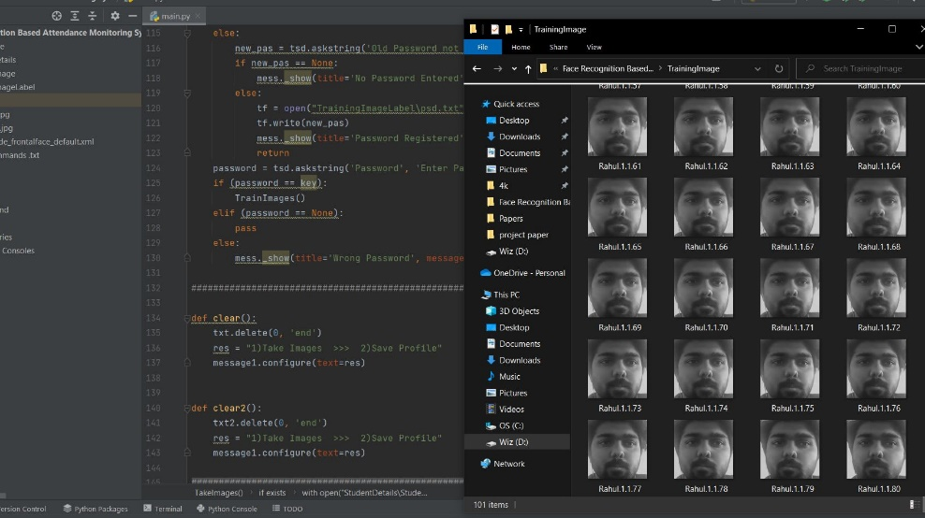

**6.4 Excel file**



**6.5 Contact Info**

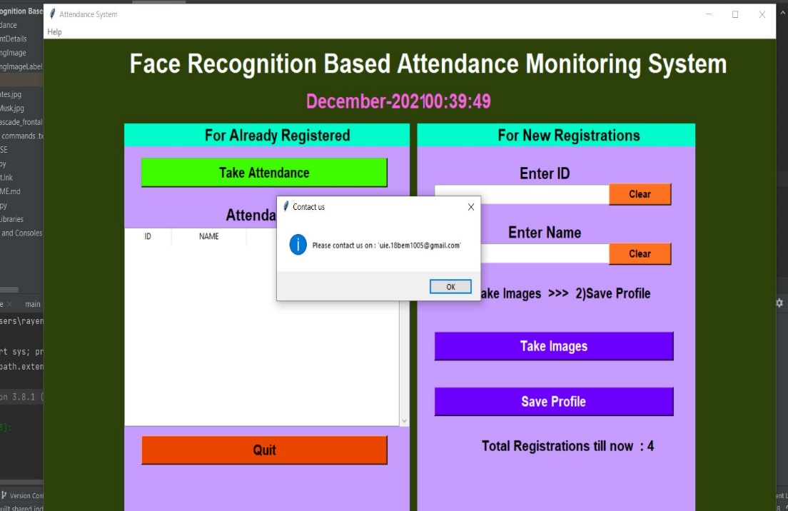

* 1. **Changing Password**

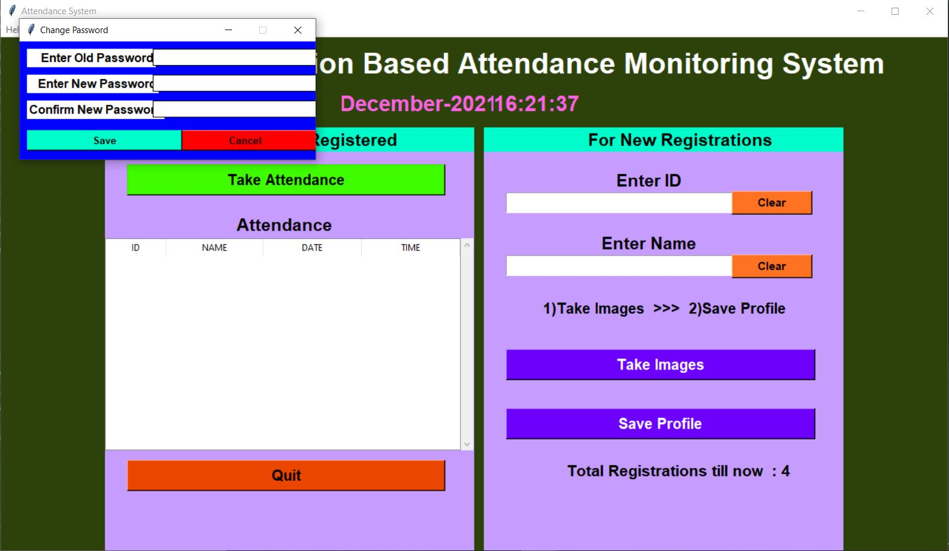

* 1. **Wrong Name**

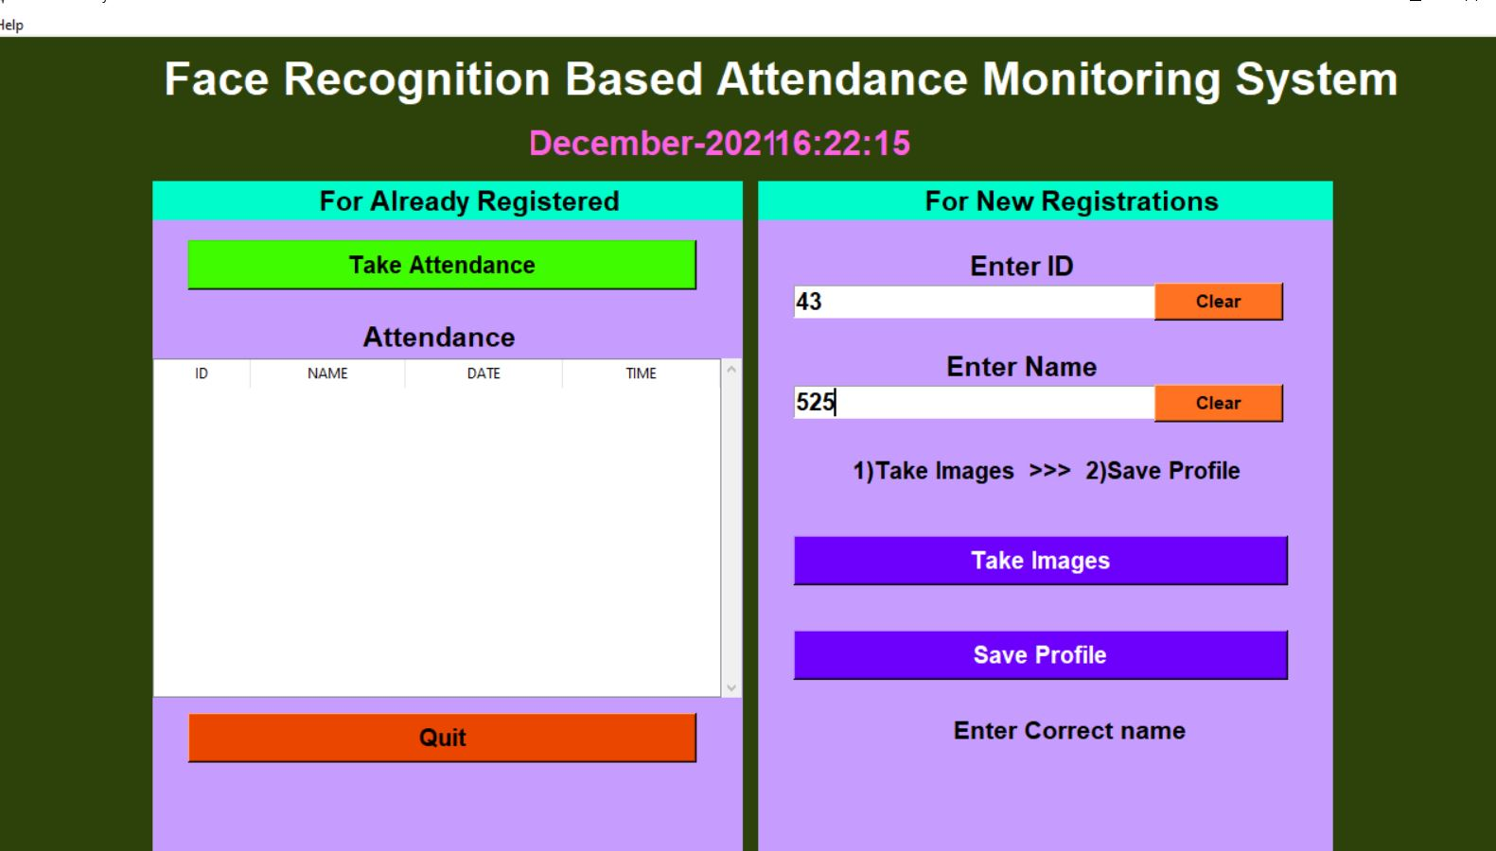

* 1. **Password for Saving profile**

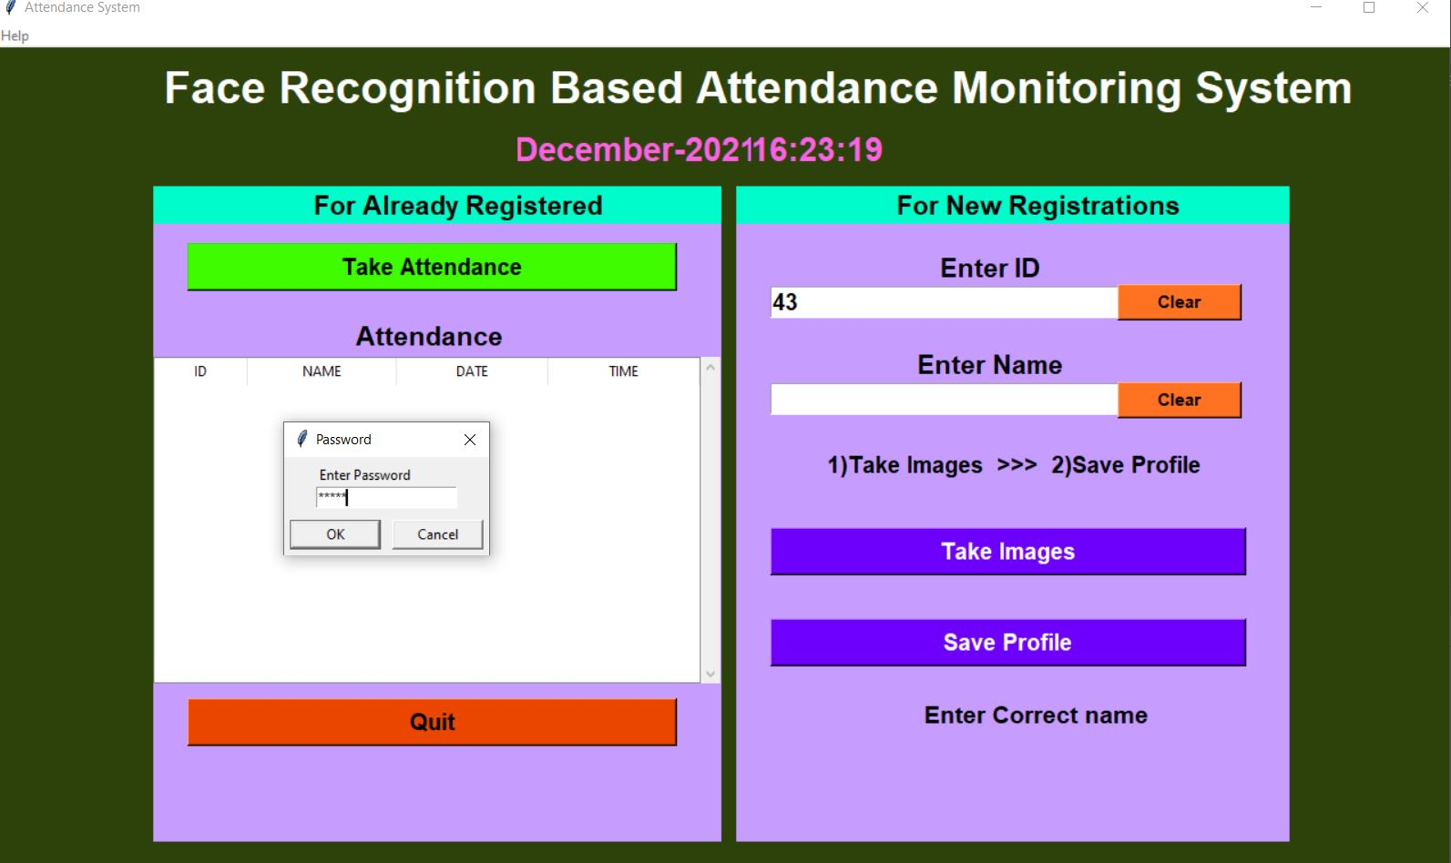

**VIII. ADVANTAGES AND APPLICATIONS**

1. Maintains Overall Records: An automated face recognition attendance system maintains the overall presence record of the students in the institution. Leaves taken by the students, date of absent each data is stored in the system.

2. Get Rid of Pen & Paper System: The newest technology helps in replacing the older paper register method efficiently. It also saves money that the organization uses to spend on the paper. Face-recognition time attendance system gives better maintenance of data as it supports the electronic medium of data storage. Also the system gives a good impression about the organization in front of the business clients and other concerned people.

3. Financial Benefits: The face-recognition time attendance system helps in saving time, eliminates the manual mistakes and controls the overall system. Since the face recognition system controls every single event electronically therefore, reduces the possibility of error. The attendance is noted down electronically therefore it saves time of the lecturers which they can use efficiently in lecturing.

4. Easy Integration: Integrated Biometric facial systems are also easy to program into any computer system. Usually they will work with existing software that one has in their place.

5. High Success Rate: Facial biometrics technology today has a high success rate, especially with the emergence of 3d face recognition technologies. It is extremely difficult to fool the system, so one can feel secure about the system.

6. Proxy attendance is eliminated: Attendance is taken automatically by the camera placed in the classroom therefore there will be no chances of proxy attendances.

7. Saves Time: In traditional attendance marking system Lecturer calls each student’s name with respect to their ids which is a very much time consuming job this system restores the time consumed for calling attendance by automatically marking attendance.

8. Less Mistakes: here will be chances of making mistakes while manually marking attendances by lecturers, while taking attendance automatically there will not be any chances of mistakes since the system is computer based.

9. Virtual Classroom: Virtual classrooms are the class rooms without the lecturers to teach as students will be learning online. This system is very useful in virtual classrooms where there will be no lecturers to take attendances this system will automatically manage the attendances of the students.

10. Simple Algorithm & Flowcharts: This system uses a simple algorithm and flowchart which is easy to understand as there are no complicated sections, information flow is simple as there is less hardware’s components used therefore each section is clearly understood

**VIII. CONCLUSION AND FUTURE SCOPE OF WORK**

**7.1 Future Scope**

The system we have developed has successfully, able to accomplish the task of marking the attendance in the classroom automatically and output is obtained in an excel sheet as desired in real-time. However, in order to develop a dedicated system which can be implemented in an educational institution, a very efficient algorithm which is insensitive to the lighting conditions of the classroom has to be developed. Also a camera of the optimum resolution has to be utilized in the system. Another important aspect where we can work towards is creating an online database of the attendance and automatic updating of the attendance into it keeping in mind the growing popularity of Internet of Things. This can be done by creating a standalone module which can be installed in the classroom having access to internet, preferably a wireless system. These developments can greatly improve the applications of the project.

**7.2 Conclusion**

In this system we have implemented an attendance system for a lecture, section or laboratory by which lecturer or teaching assistant can record students’ attendance. It saves time and effort, especially if it is a lecture with huge number of students. Automated Attendance System has been envisioned for the purpose of reducing the drawbacks in the traditional (manual) system. This attendance system demonstrates the use of image processing techniques in classroom. This system can not only merely help in the attendance system, but also improve the goodwill of an institution

**IX. REFERENCES**

[1]. “Attendance System Using NFC Technology with Embedded Camera on Mobile Device” (Bhise, Khichi, Korde,Lokare, 2015)

[2]. K.SenthamilSelvi, P.Chitrakala, A.AntonyJenitha, "Face Recognition Based Attendance Marking System", IJCSMC, Vol. 3, Issue.

2, February 2014.

[3]. “Fingerprint Based Attendance System Using Microcontroller and LabView” (Kumar Yadav, Singh, Pujari, Mishra, 2015)

[4]. “RFID based Student Attendance System” (Hussain, Dugar, Deka, Hannan, 2014)

[5]. OpenCvDocumentation -https://opencv.org

[6]. Numpy - https://numpy.org

[7] M. T. a. A. Pentland, "Eigenfaces For Recognition," Journal of Cognitive

Neuroscience, vol. 3, no. 1, 1991.

[8] A. V. a. R. Tokas, "Fast Face Recognition Using Eigen Faces," IJRITCC, vol. 2, no.

11, pp. 3615-3618, November 2014.

[9] Paul Viola and Michael J. Jones, "Robust Real-Time Face Detection," International

Journal of Computer Vision, vol. 57, no. 2, pp. 137-154, May 2004.

[10] N. J. M. M. K. a. H. A. Mayank Agarwal, "Face Recognition Using Eigenface

aproach," IRCSE, vol. 2, no. 4, pp. 1793-8201, August 2010.

[11] Vinay Hermath, Ashwini Mayakar, "Face Recognition Using Eigen Faces and,"

IACSIT, vol. 2, no. 4, pp. 1793-8201, August 2010.

[12] Smart Attendance System using Computer Vision and Machine Learning Dipti Kumbhar#1 , Prof. Dr. Y. S. Angal*2 # Department of Electronics and Telecommunication, BSIOTR, Wagholi, Pune, India 1 diptikumbhar37@gmail.com , 2 yogeshangal@yahoo.co.in

[13] ATTENDANCE SYSTEM USING MULTI-FACE RECOGNITION1P. Visalakshi, 2Sushant Ashish 1Assistant Professor 1,2Department of Computer Science and Engineering SRM Institute of Science and Technology, Chennai, Tamil Nadu, INDIA

[14] Face Recognition Based Student Attendance System with OpenCVCH. VINOD KUMAR1 , DR. K. RAJA KUMAR2 1 PG Scholar, Dept of CS& SE, Andhra University, Vishakhapatnam, AP, India. 2Assistant Professor, Dept of CS& SE, Andhra University, Vishakhapatnam, AP, India.

[15] Automatic Attendance System Using Face Recognition. Ashish Choudhary1,Abhishek Tripathi2,Abhishek Bajaj3,Mudit Rathi4 and B.M Nandini5 1,2,3,4,5 Information Science and Engineering, The National Institue of Engineering,

[16] Face Recognition based Attendance Management System using Machine Learning Anushka Waingankar1, Akash Upadhyay2, Ruchi Shah3, Nevil Pooniwala4, Prashant Kasambe5

[17] https://www.superdatascience.com/blogs/opencv-face-recognition

[18] https://towardsdatascience.com/face-recognition-how-lbph-works90ec258c3d6b

[19] https://www.pyimagesearch.com/2018/09/24/opencv-facerecognition/

[20] http://nxglabs.in/cloud/impact-biometric-attendance-systemeducational-institutes.html

[21] https://iopscience.iop.org/article/10.1088/1757-899X/263/4/042095/pdf

[22] http://www.ijsrp.org/research-paper-0218/ijsrp-p7433.pdf

[23] <https://www.theseus.fi/bitstream/handle/10024/132808/Delbiaggio_Nicolas.pdf>?

sequence=1&isAllowed=y [24] M. A. Turk and A. P. Pentland, “Face Recognition Using Eigenfaces,” in Proc. IEEE Conference on Computer Vision and Pattern Recognition, pp. 586–591. 1991.

[25] A. J. Goldstein, L. D. Harmon, and A. B. Lesk, “Identification of Human Faces,” in Proc. IEEE Conference on Computer Vision and Pattern Recognition, vol. 59, pp 748 – 760, May 1971.

[26] T. Ahonen, A. Hadid, M. Peitikainen, Face recognition with local binary patterns. “In Proc. of European Conference of Computer Vision”, 2004.

[27] M. H. Yang, N. Ahuja, and D. Kriegmao, “Face recognition using kernel eigenfaces,” IEEE International Conference on Image Processing, vol. 1, pp. 10-13, Sept. 2000.

[28] Y. Zhang and C. Liu, “Face recognition using kemel principal component analysis and genetic algorithms,” IEEE Workshop on Neural Networks for Signal Processing, pp. 4-6 Sept. 2002.

[29] M. A. Fischler and R. A. Elschlager, “The Representation and Matching of Pictorial Structures,” IEEE Transaction on Computer, vol. C22, pp. 67-92, 1973.

[30] P. Sinha, B. Balas, Y. Ostrovsky, and R. Russell, “Face Recognition by Humans: Nineteen Results All Computer Vision Researchers Should Know About,” in Proceedings of the IEEE, vol. 94, Issue 11, 2006.

[31] A. T. Acharya and A. Ray, Image Processing: Principles and Applications, New York: Wiley, 2005.

[32] T. D. Russ, M. W. Koch, and C. Q. Little, “3D Facial Recognition: A Quantitative Analysis,” 38th Annual 2004 International Carnahan Conference on Security Technology, 2004.

[33] S. S. R. Abibi, “Simulating evolution: connectionist metaphors for studying human cognitive behaviour,” in Proceedings TENCON 2000, vol. 1 pp 167-173, 2000.

[34] B. Tacacs and H. Wechsler. Face recognition using binary image metrics. In Proceedings, Third International Conference on Automatic Face and Gesture Recognition, pages 294–299, April 1998.

[35] Y. Cui, J. S. Jin, S. Luo, M. Park, and S. S. L. Au, “Automated Pattern Recognition and Defect Inspection System,” in proc. 5 th International Conference on Computer Vision and Graphical Image, vol. 59, pp. 768 – 773, May 1992.